WEEK 5 Assignment

In this week’s assignment we were given various tasks to perform on databases.

1. Copy data from Database to CSV, Parquet and Avro File Format.
2. Configure Schedule Trigger, Event triggers to automate the pipeline process.
3. Copy all the tables from one database to another.
4. Copy selective tables with selective columns from one database to another.

For 1st task we used jupyter notebook and python to convert data from csv to parquet and Avro file format. I have uploaded the file in which the conversion code was written in this repository. File name:” pizza_sales.ipynb”.

For 2nd task we needed to perform some triggers to automate the pipeline process which also we have done in” pizza_sales.ipynb” and it is uploaded along with this file.

For 3rd and 4th task I have used MySQL Workbench to copy selective tables from one database to another and also selective columns are also copied. This I have achieved using MySQL Workbench import/export wizard. It is a tool which helps in importing and exporting tables and databases into other databases and exporting the tables outside the database also in csv format.

Screenshots of the Import/Export wizard is attached below:

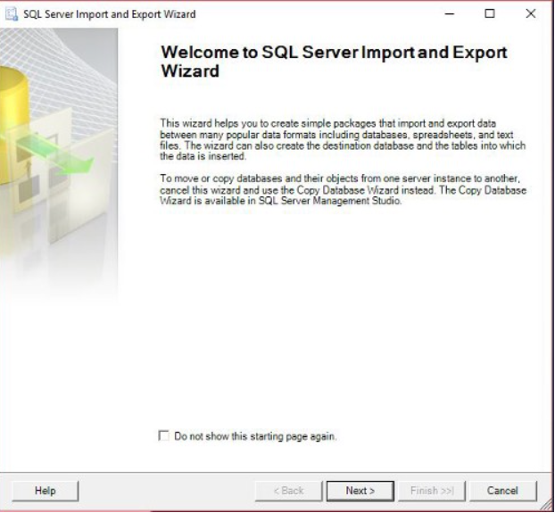

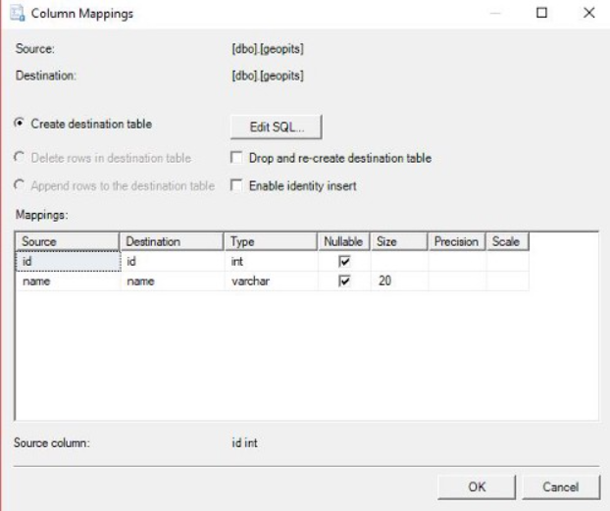

This wizard helps us to perform copying of tables from one database to another and modifying the table in between if we want to make any changes and we can also export data in any popular format we want.